Task for git and github

1)Install git.
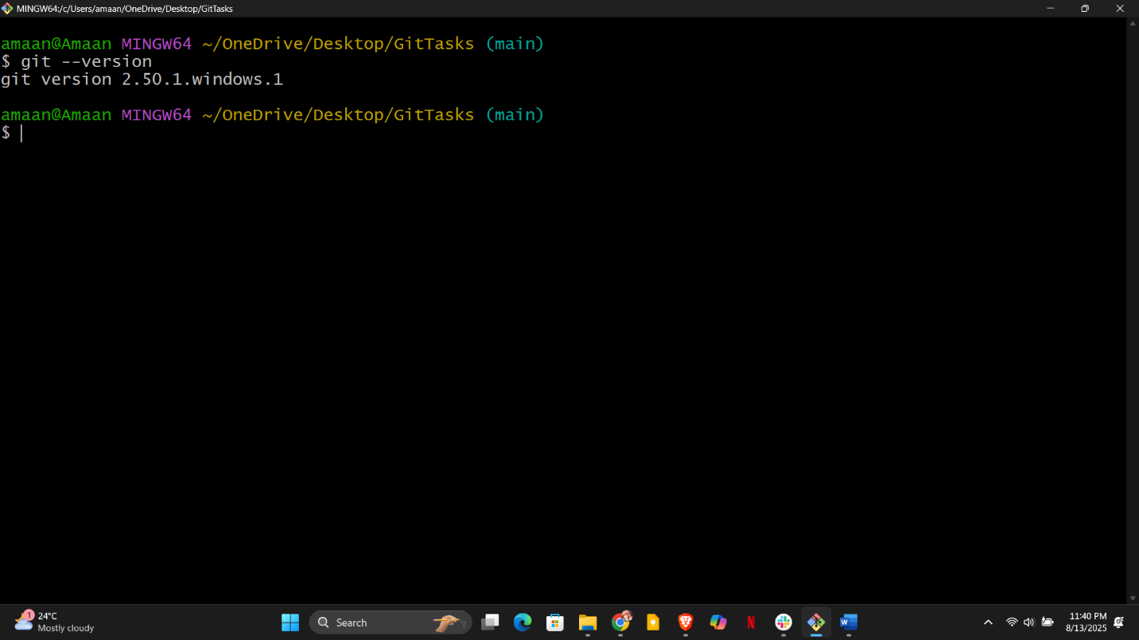
2)Create a repo in github with README.md and .ignore file.
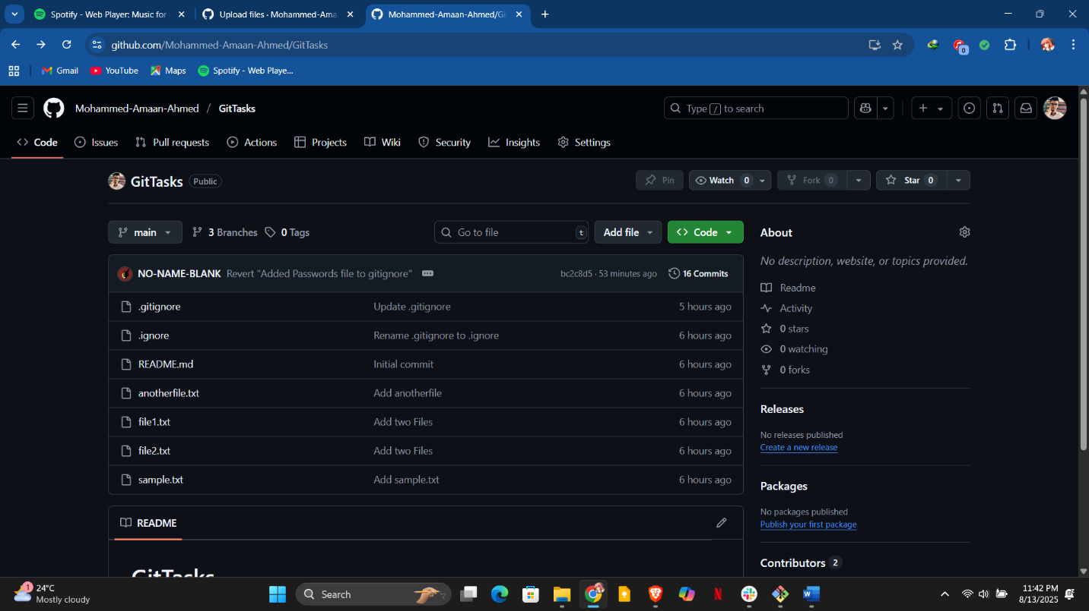
3)Clone the created repo to local.
4)Create two files in local repo.
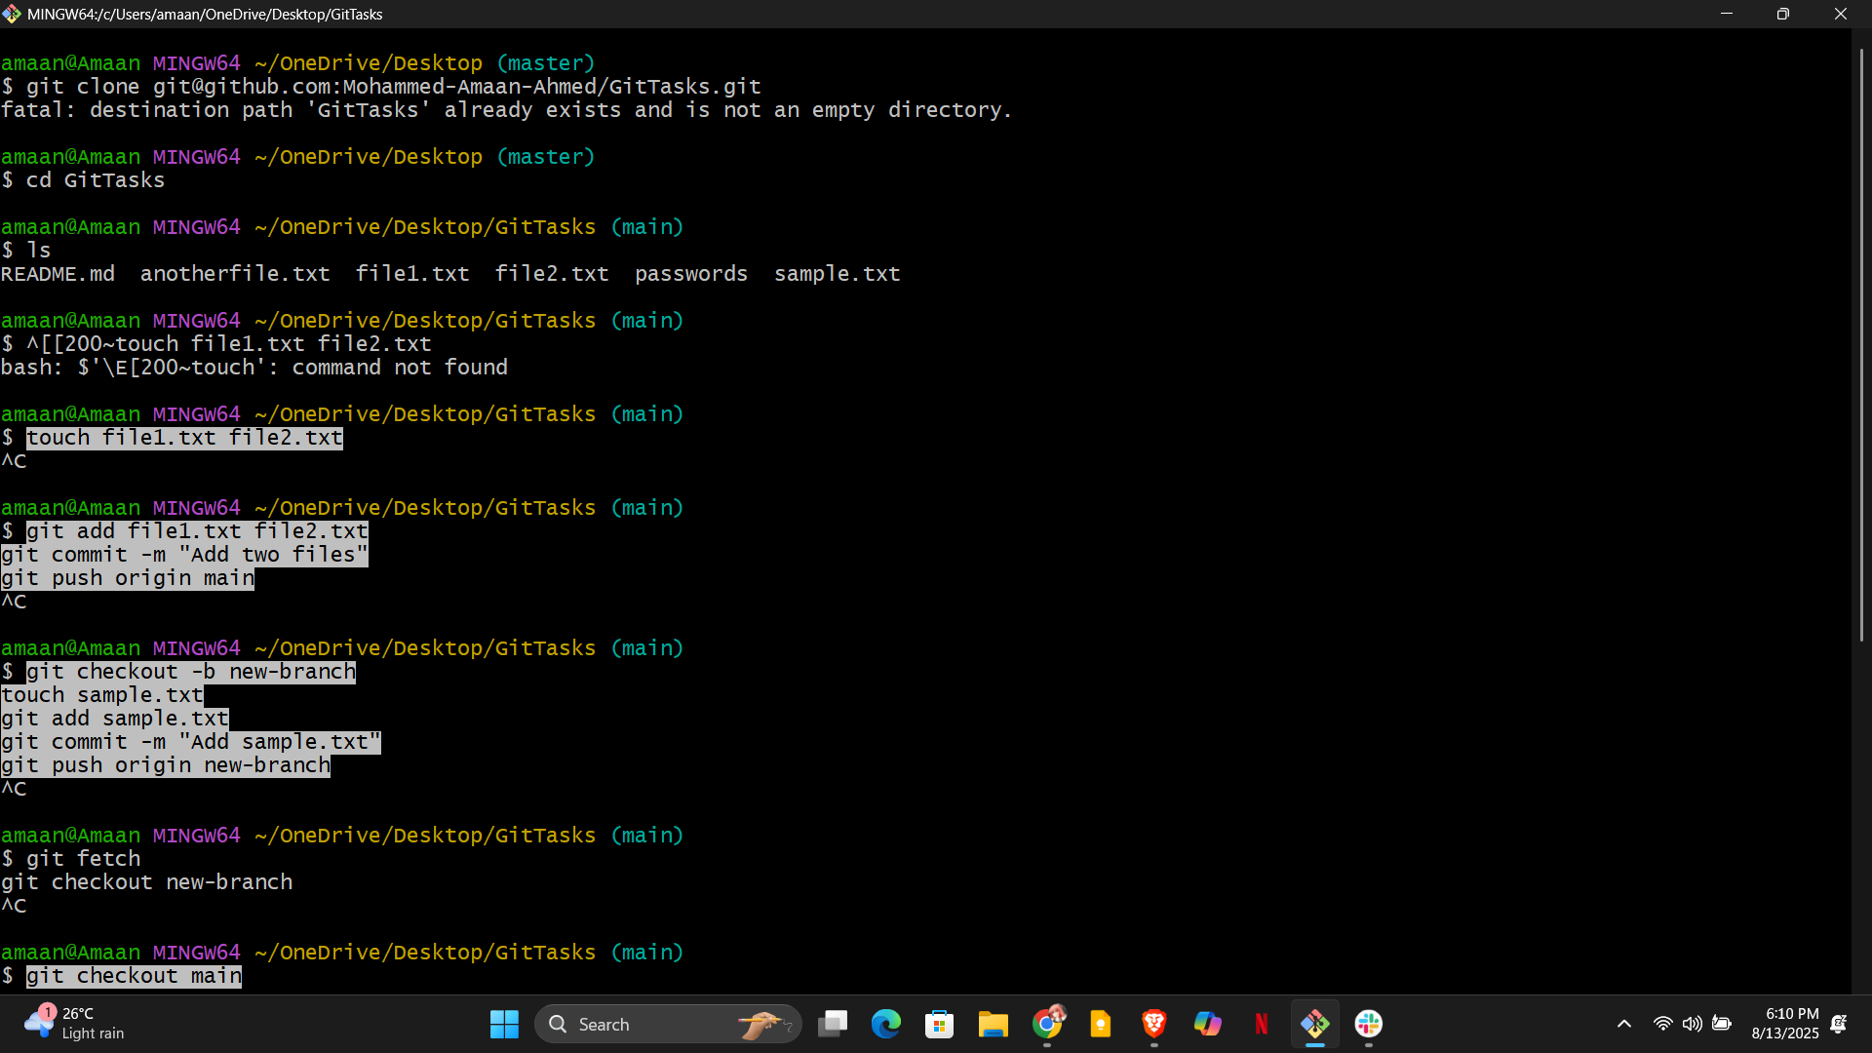

5)Commit two files and push to central Repository.
6)Create a branch in local and create a sample file and push to central.
7)Create a branch in github and clone that to local.
8)Merge the created branch with master in git local.
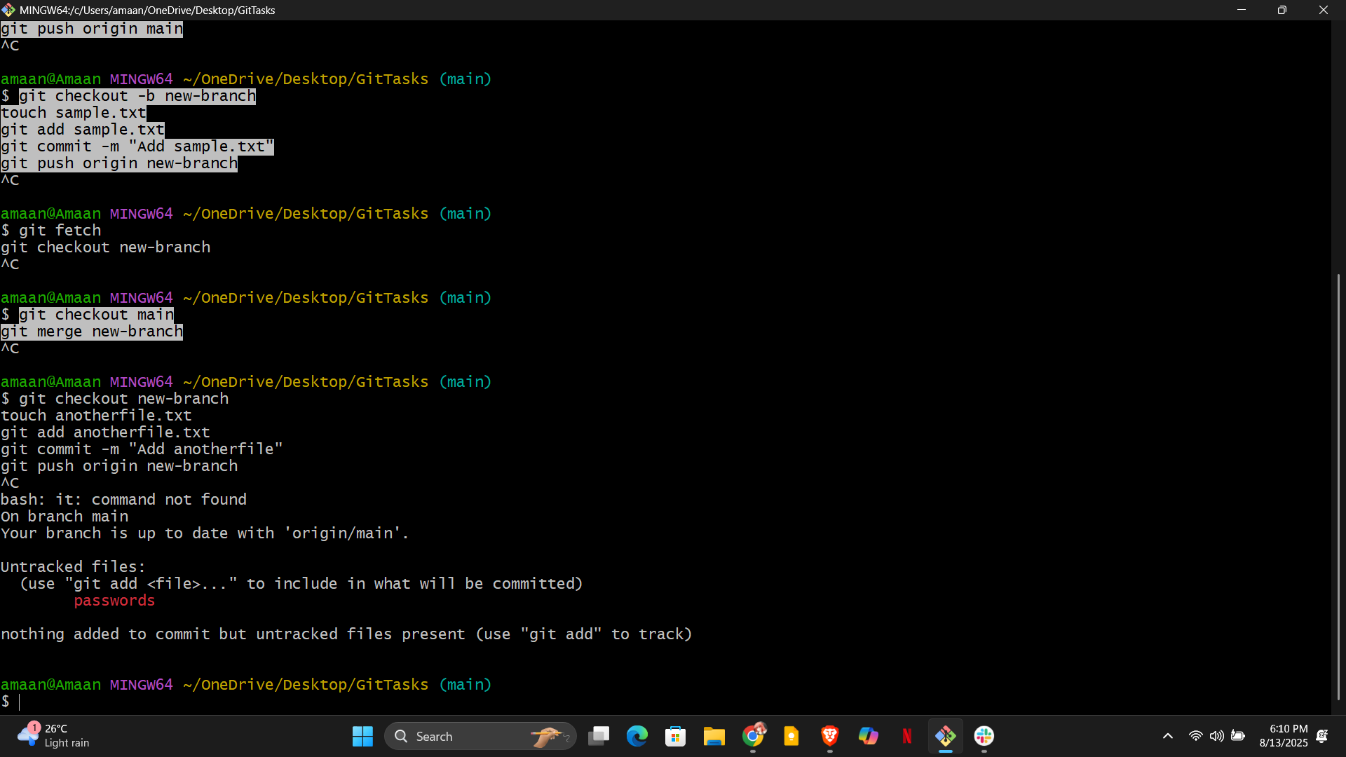
9)Merge the created branch with master in github by sending a pull request.
10)create a file in local and send that to branch in github.
11)clone only a branch from github to local.
12)create a file with all passwords and make that untrackable with git.
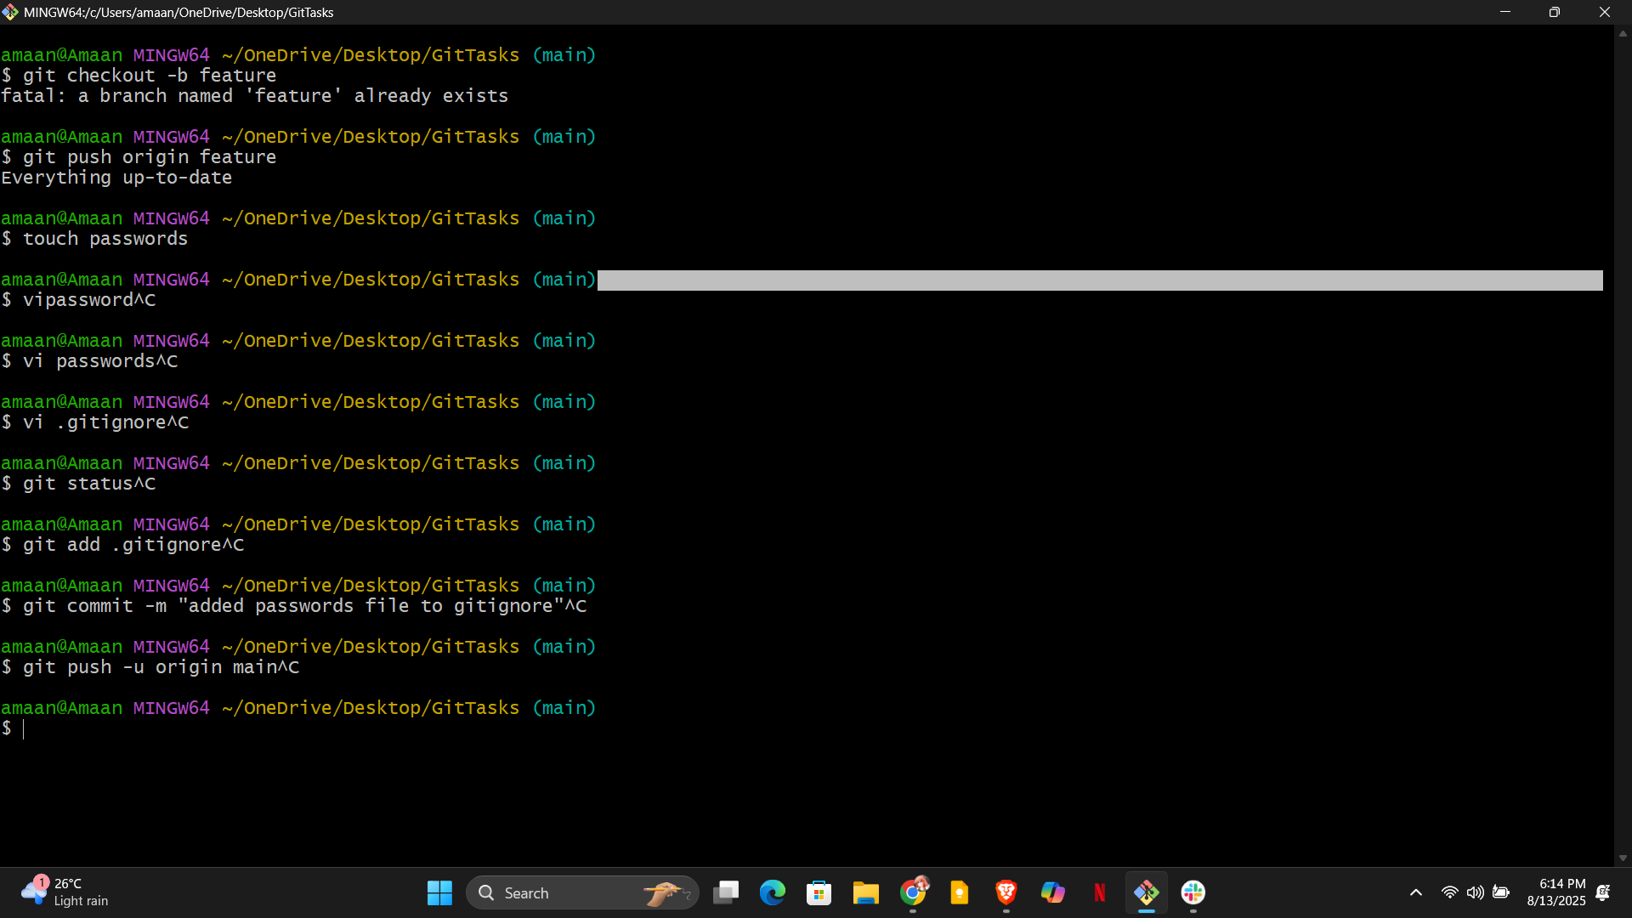13)make a commit and make that commit reset without savings changes.
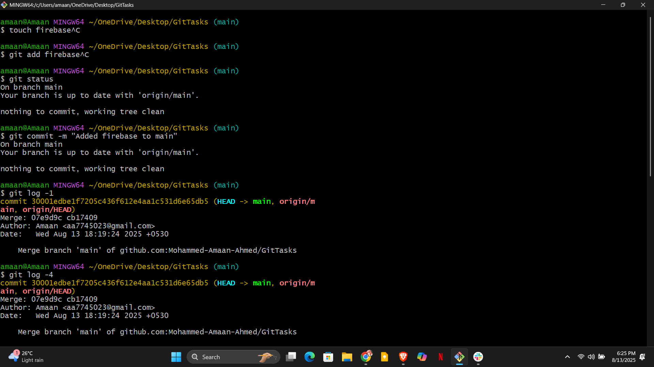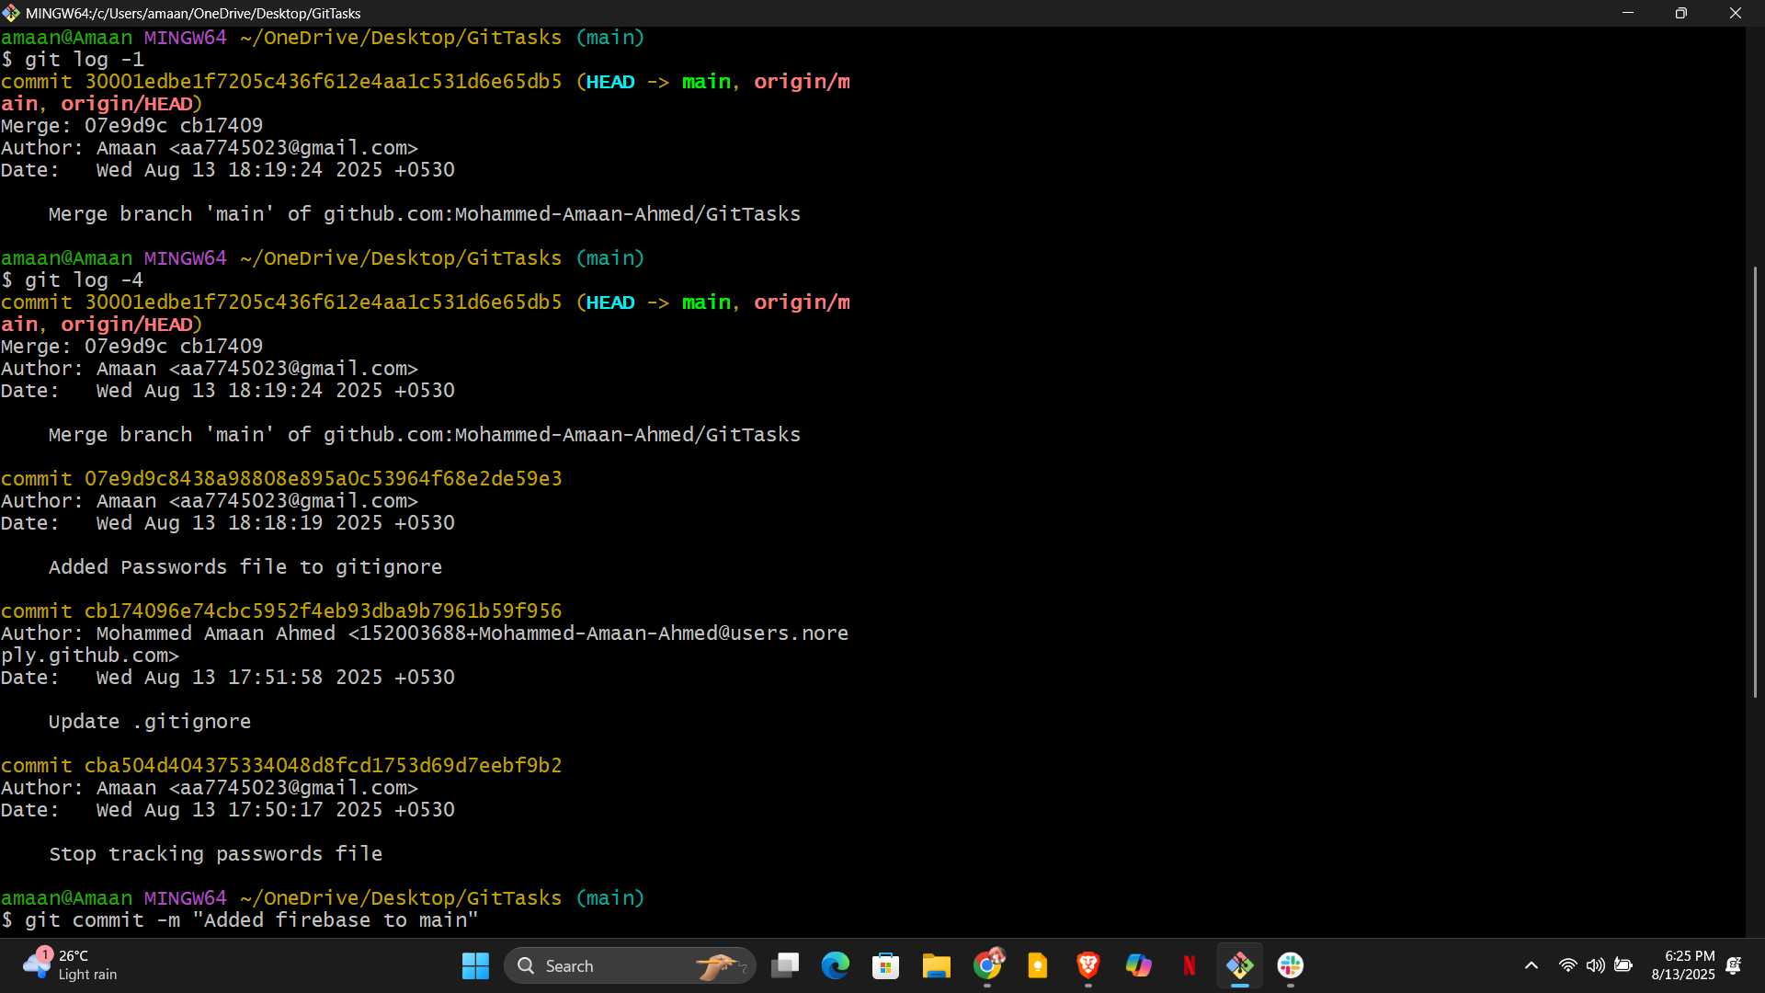
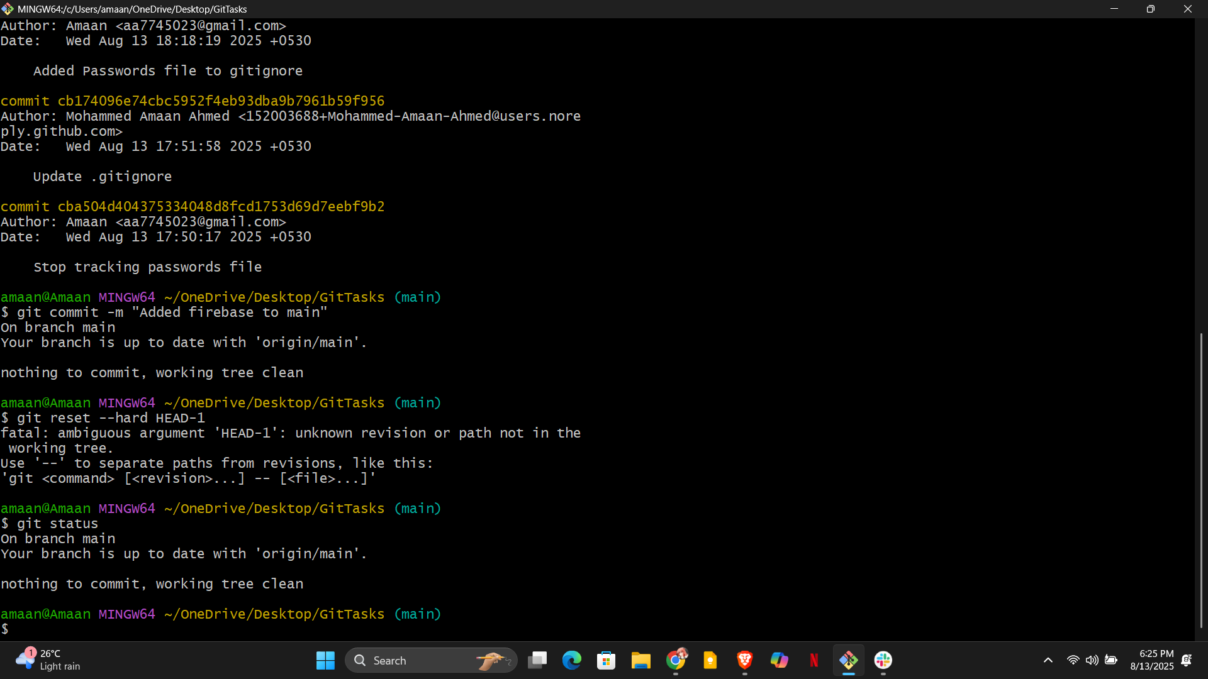
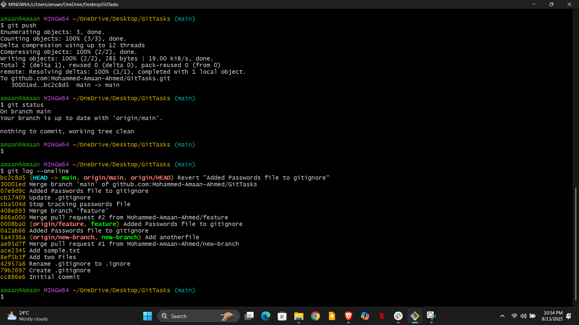

14)Revert a commited commit to the older version.
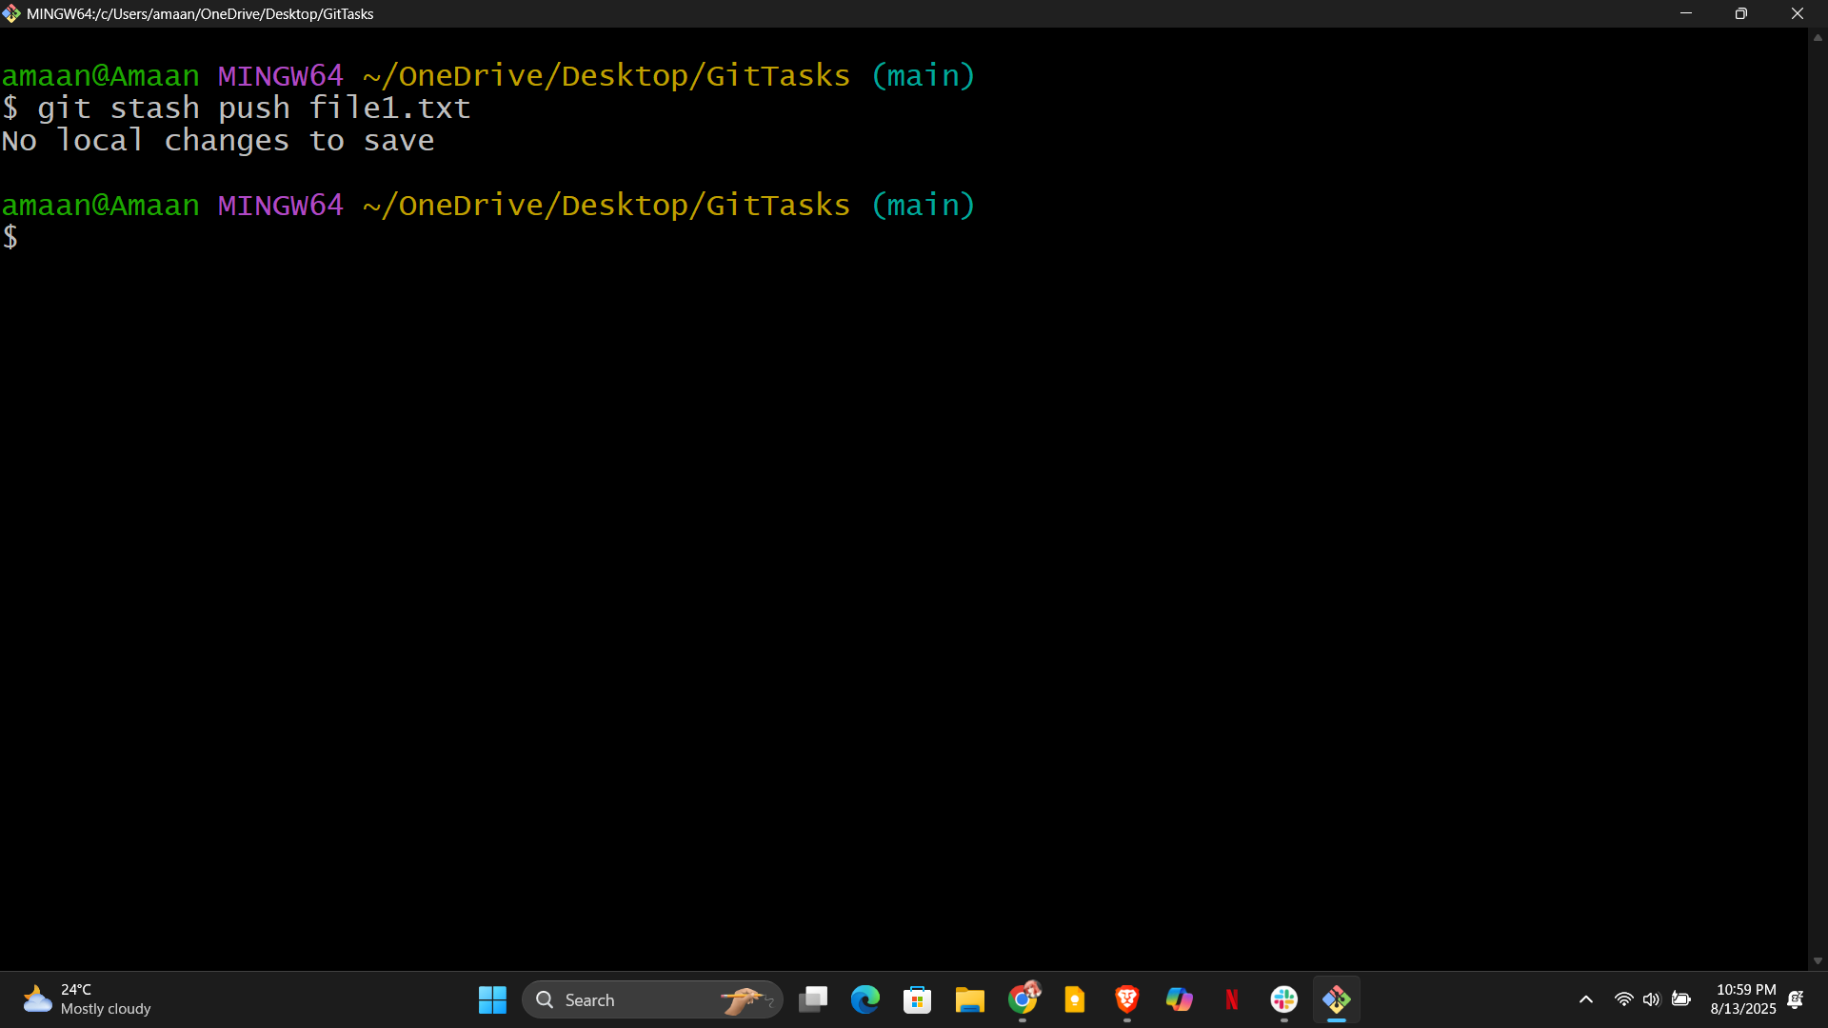

15)push a file to stash without savings the changes and work on another file.
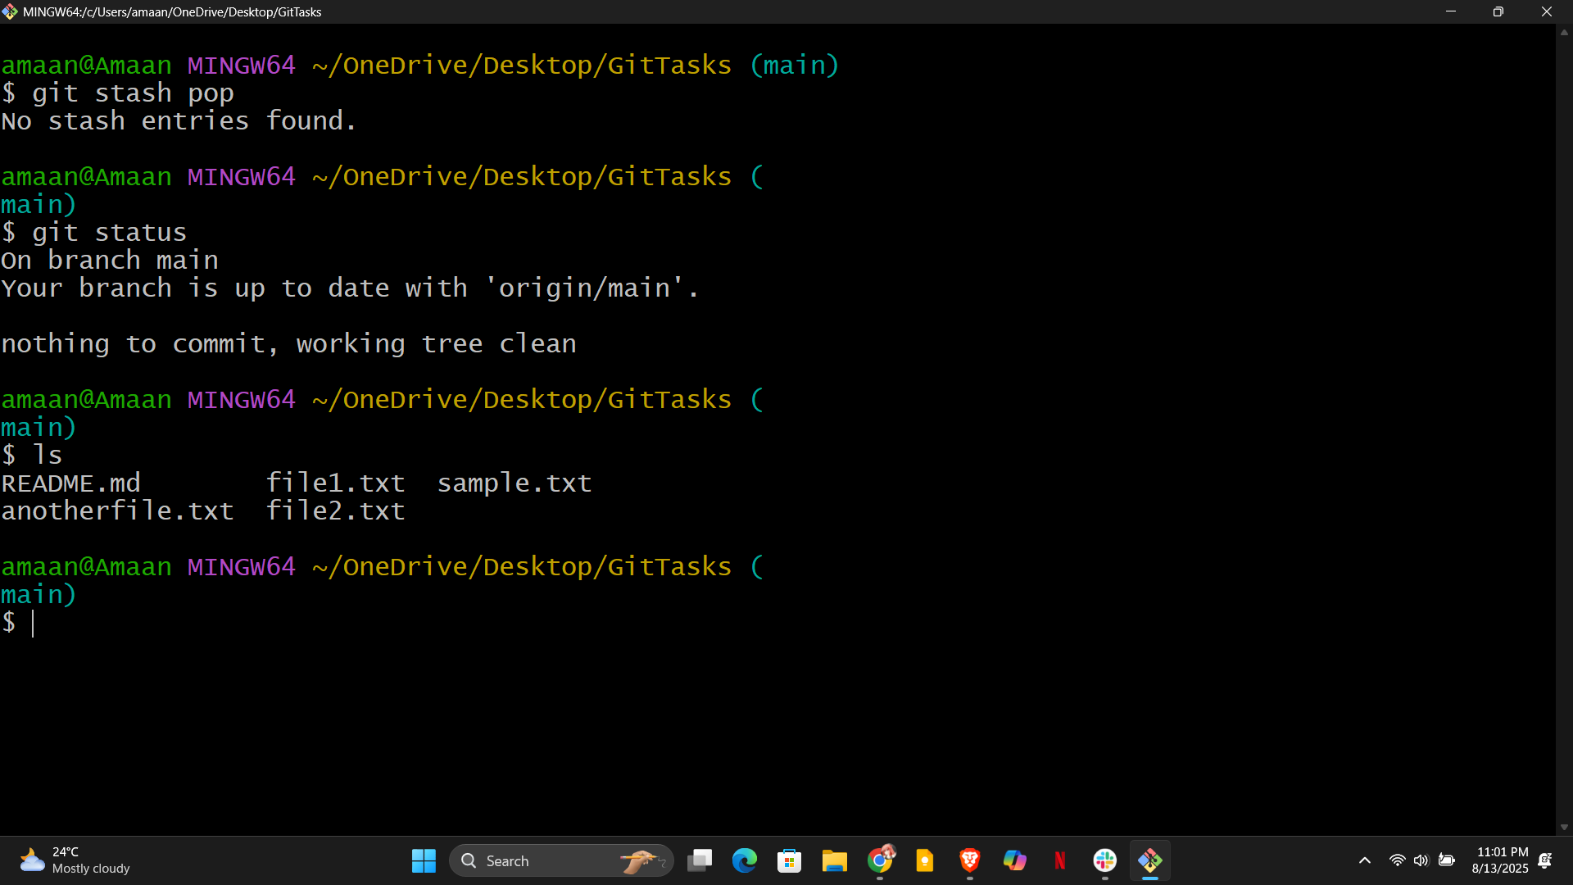

16)undo the stash file and start working on that again.

17. Generate a ssh-keygen and configure in github.
18)configure webhooks to github.
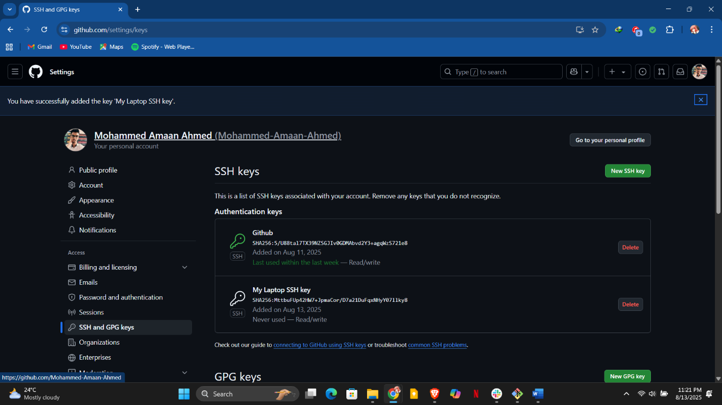
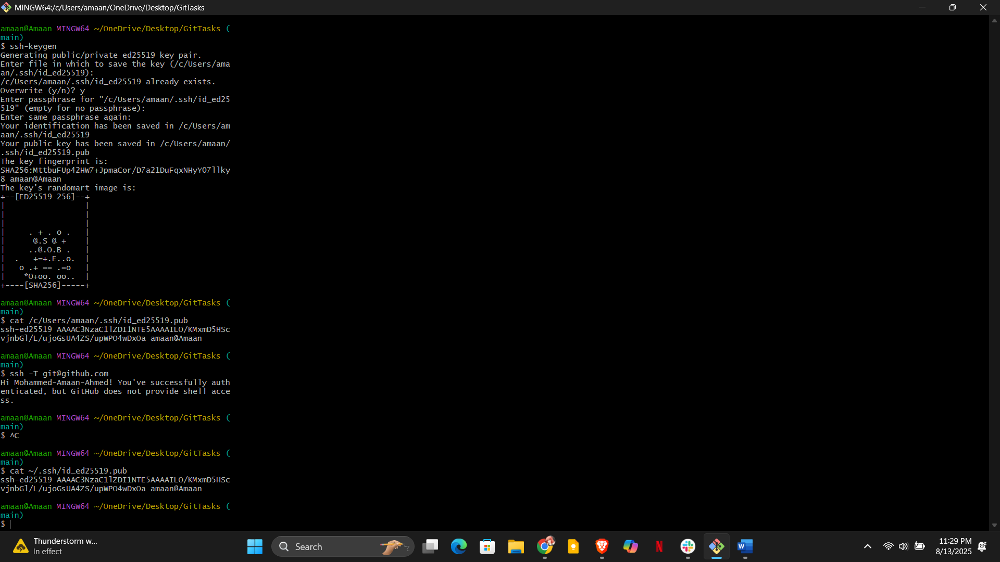
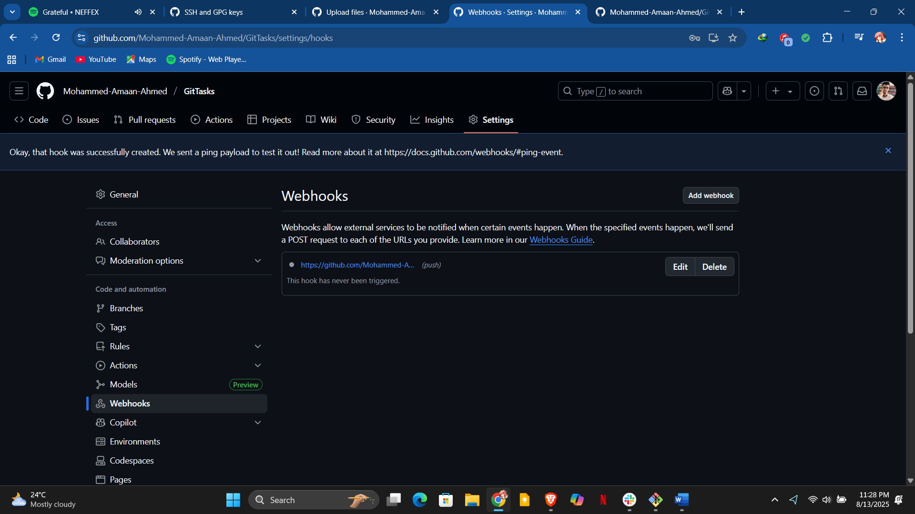

19. Basic understanding of .git file
- The .git folder holds all your repo’s metadata, configurations, history, and objects.
- 20. Check all the logs of git
- 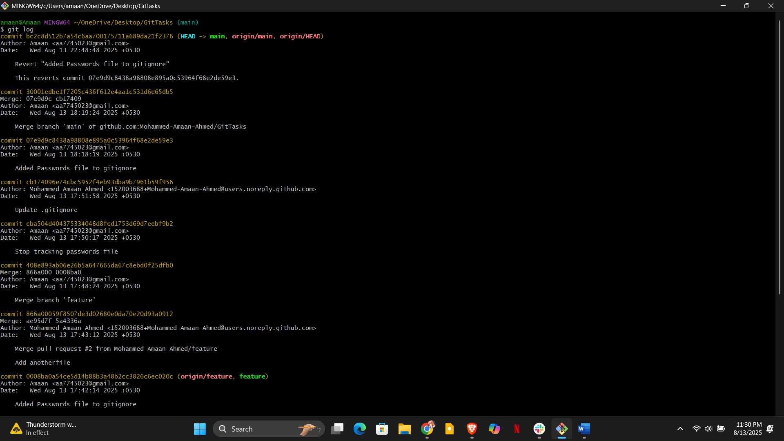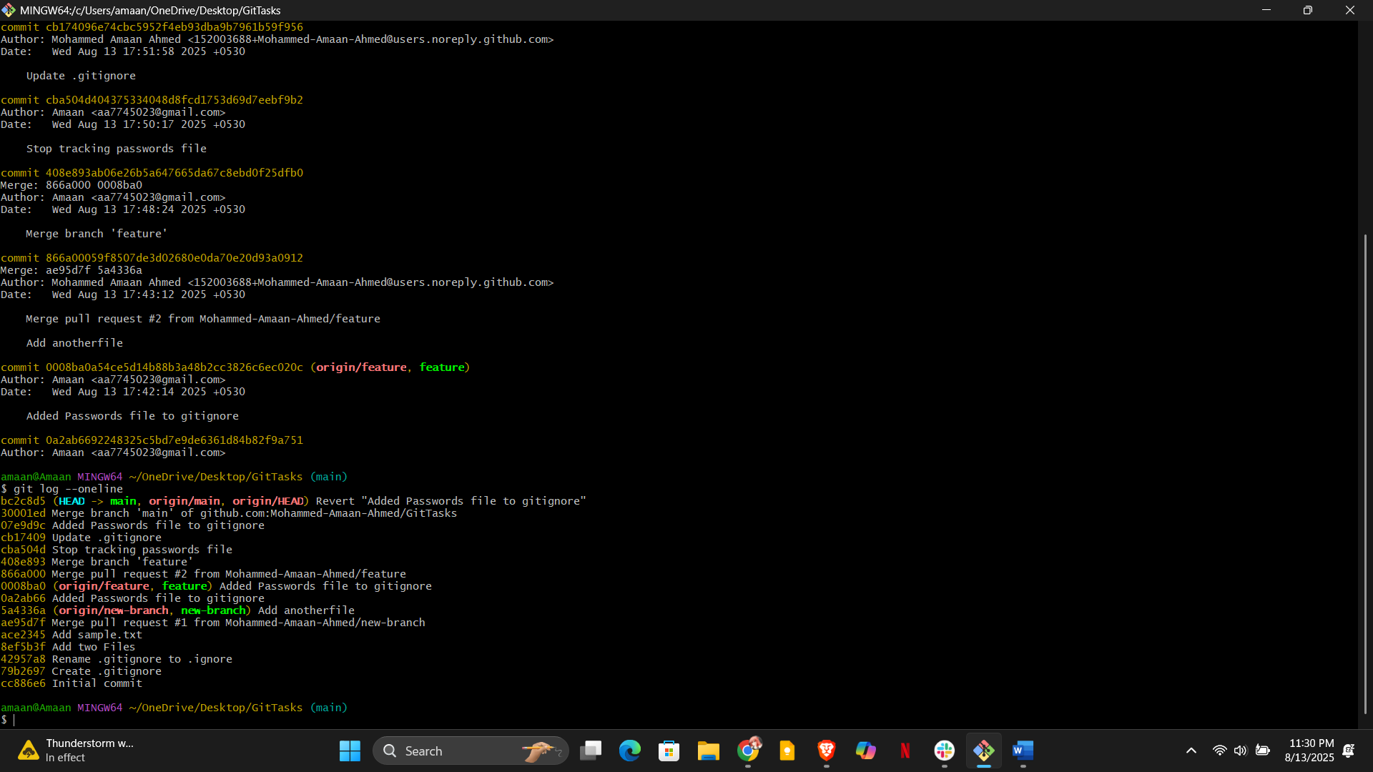
- 21. Rename the commit message

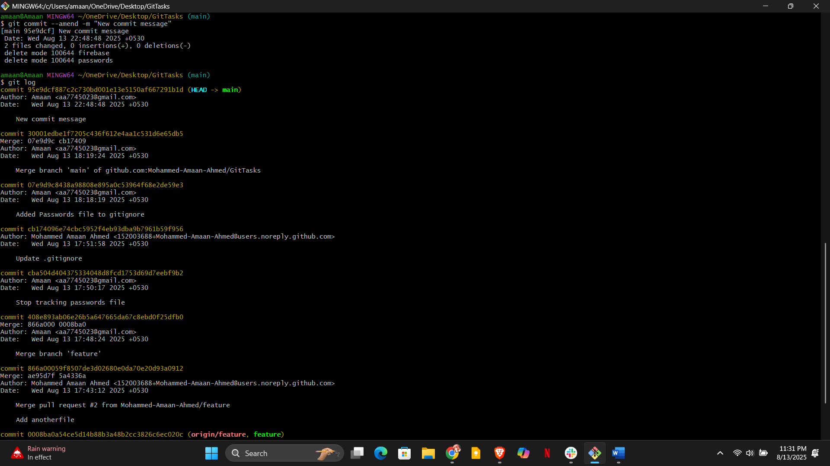

22. Merge multiple commits into single commit
